Assignment 02: Configuring Cisco Switches
Station 02

Brian Batinchok
Ryon Riley
Phillip Moncrief

Step 02: Use Putty to connect to the switch.

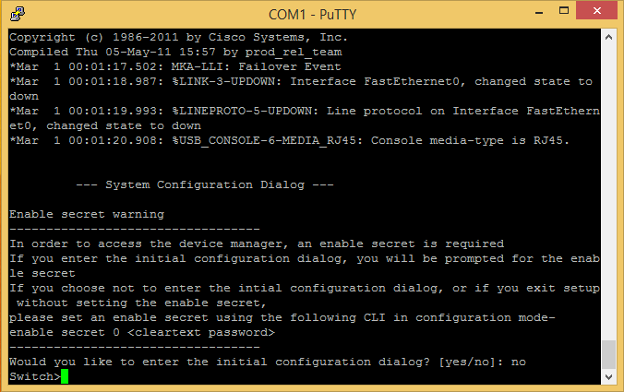

Step 03: Step 02 of the Lab Assignment

Configure switch 1 (SW1) to operate in the network using the IP address, subnet mask, and gateway address specified in Table 1.

SW1# configure terminal
SW1(config)# int vlan 1
SW1(config-if)# ip address 192.168.21.10 255.255.255.240
SW1(config)# ip default-gateway 192.168.21.1
SW1(config)#

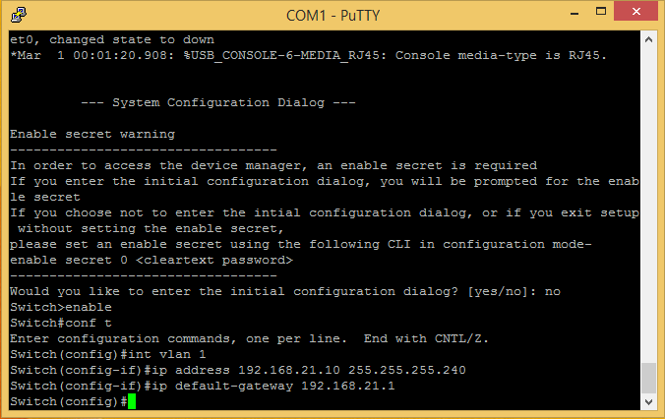

Step 04: Step 03 of the Lab Assignment

What command is used to enter the switch’s privileged mode? List the prompt and the command.

SwitchA>enable
SW1#

Enable is used to enter the switch’s privileged mode. To enter global configuration mode, use configure terminal (or conf t).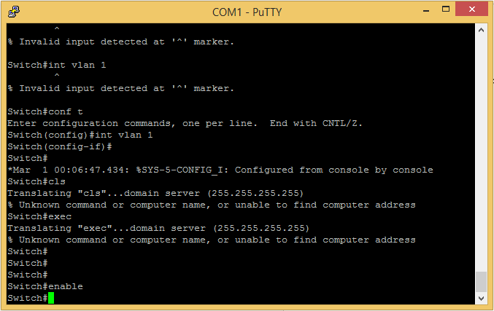

Step 05: Step 04 of the Lab Assignment (A-J)

- What happens when you enter a ? at the switch# prompt?

This will display the available commands in the privileged EXEC mode.

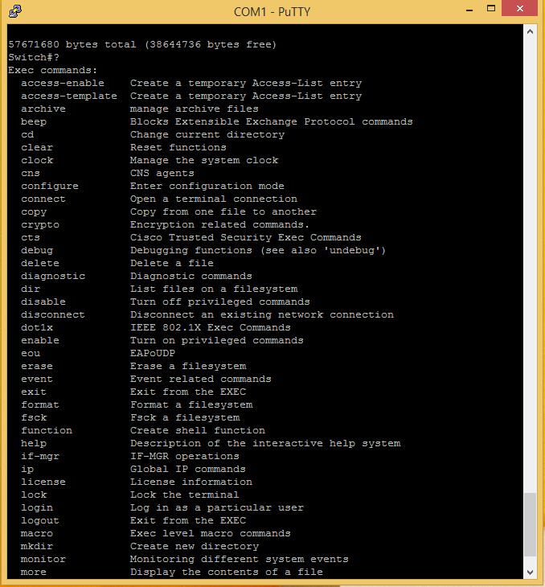

- What information is displayed when you enter show flash at the switch# prompt?

Shows the version of flash installed and the Vlan.dat information.

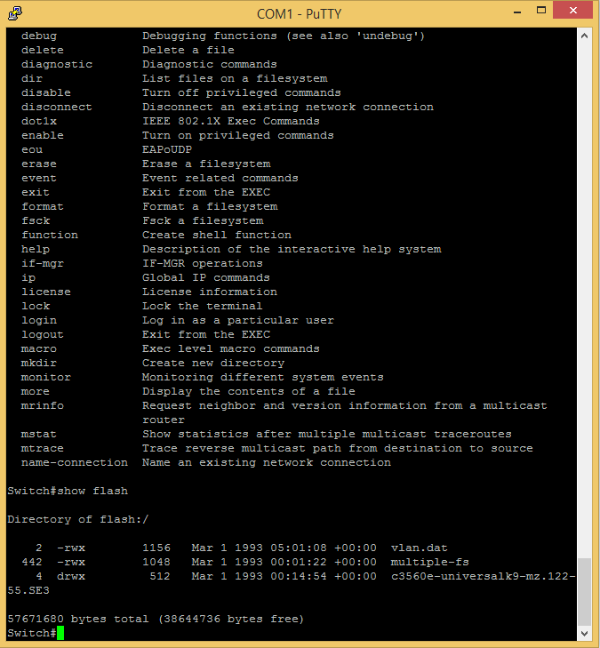

- What command can you use to view the switch’s uptime?

SW1# show version

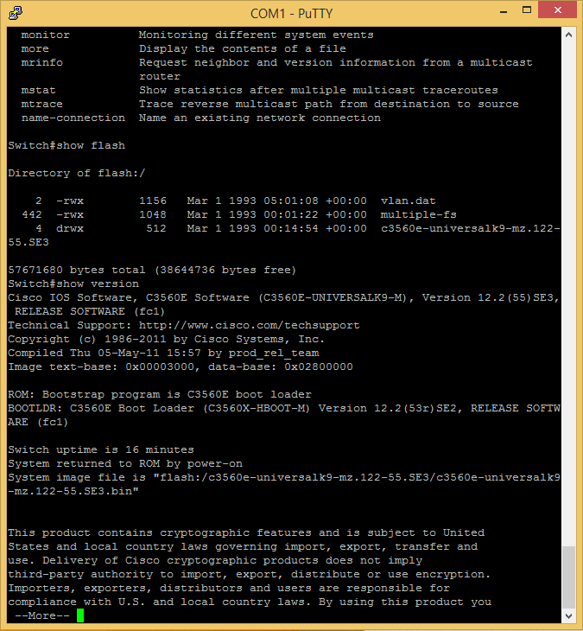

- How long has the switch been up?

16 minutes

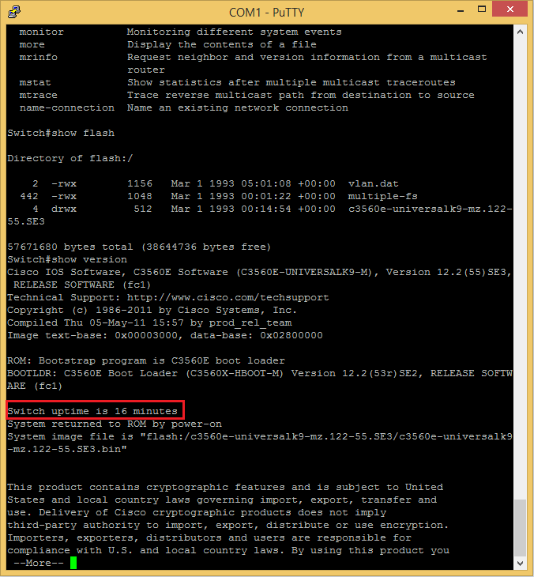

- What version of the Cisco IOS software is running on this simulator?

Cisco IOS Software, C3560E Software (C3560E-UNIVERSALK9-M), Version 12.2(55)SE3, RELEASE SOFTWARE (fc1)

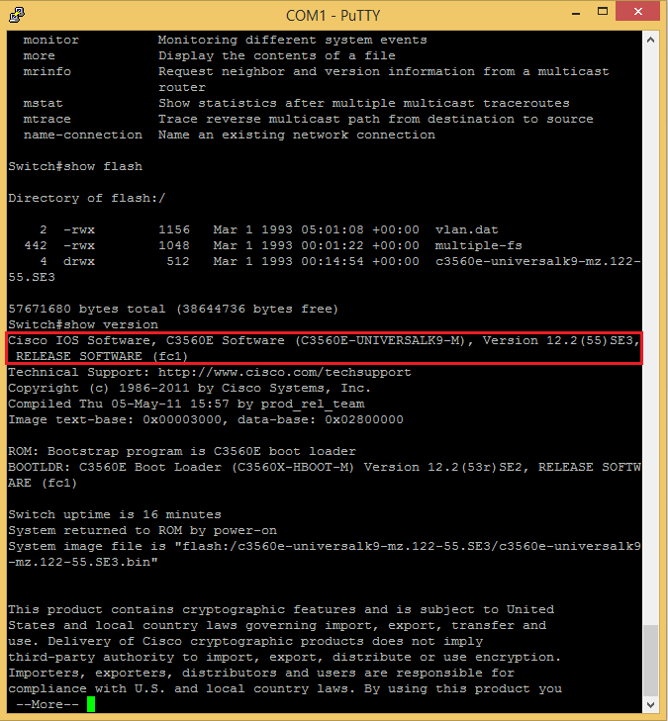

- What command can you use to view the past entries on this switch?

SW1# show history

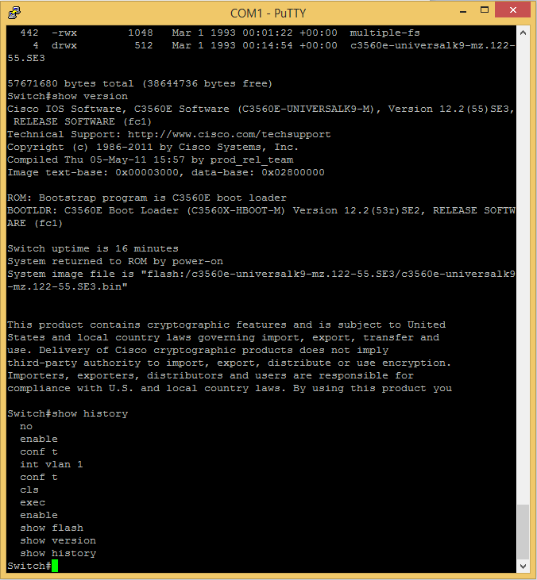

- What happens when you press the up/down keys on your keyboard?

You are able to cycle through previous commands.

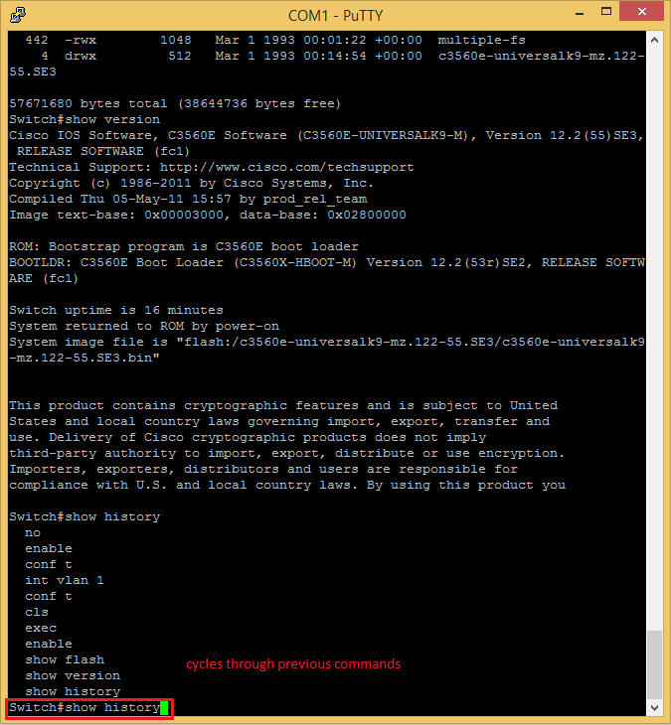

- What is the command for listing the switch’s current configuration?

SW1# show running-config

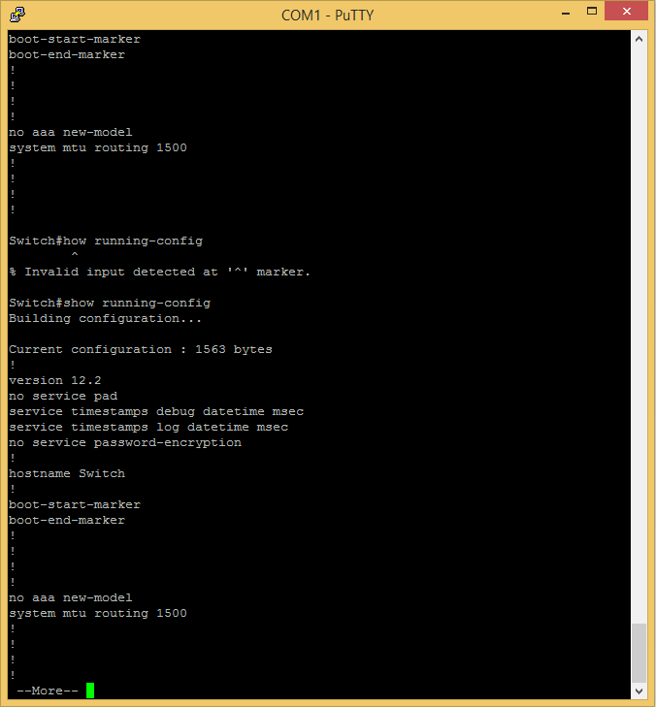

- How many FastEthernet interfaces does the switch have?

One FastEthernet interface

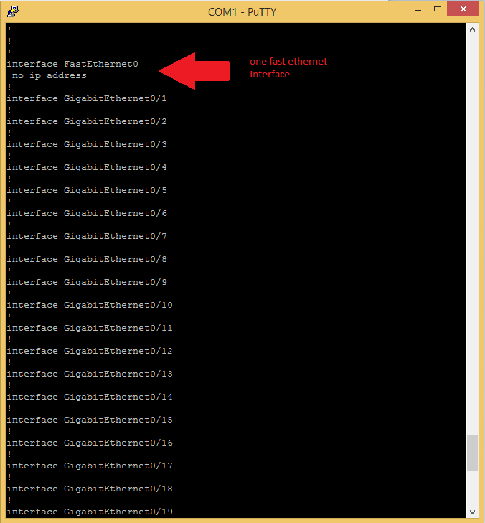

- How many Gigabit interfaces does the switch have?

24 Gigabit Ethernet interfaces

